Wordle Extra Credit Opportunity
Directions: Create a Wordle image for the chapter you choose. You may do a wordle project on chapters 1-16, besides chapter 9.

The Chapter number and title in size 60 font (resize if needed) and in the Footlight MT Light font style.
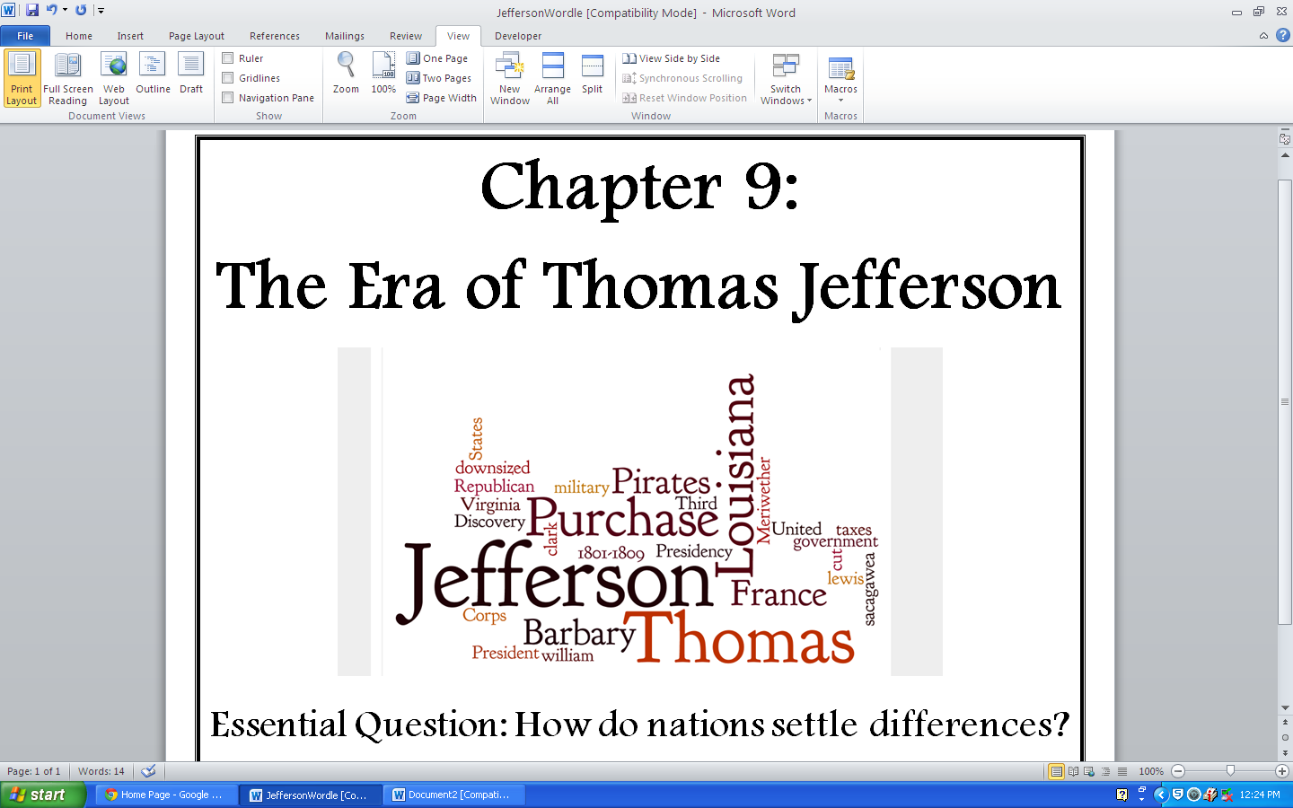
The wordle image, use the screen shot feature on the pc (ctrl+print screen or fn+end) to get the image and then crop out all but the image.
The chapter essential question must be included on the bottom, size 32 Footlight MT Light font style.

Grading: Total Extra Credit Points Possible – 10
1-5 grade will be assigned regarding the quality of the wordle, 1-5 grade will be assigned according to the requirements
Your project should look exactly like the example above!

